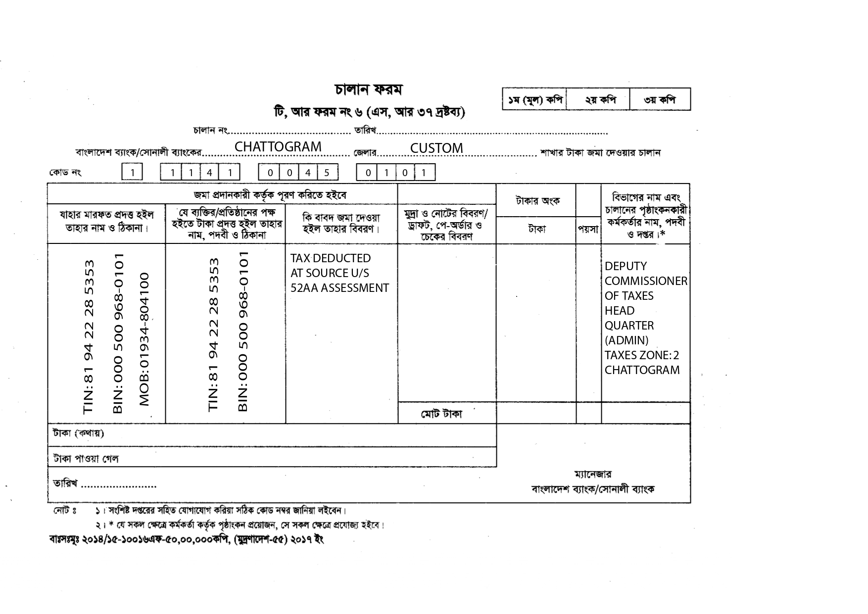

${day}/${month}/${year}

YEAR: ${yearprev}-${year}
MV. ${vessel}
NRT: ${vsl_nrt} X 10/-
TK: ${vat10amount}/-
10% AIT ON
LIGHT DUES
TK: ${vat10}/- ${vat10}/-
${vat10amountinword}

COMMENTS: 10% AIT ON LIGHT DUES OF MV. ${vessel}

